MINISTRY OF EDUCATION AND SCIENCE OF UKRAINE
NATIONAL TECHNICAL UNIVERSITY
"KHARKIV POLYTECHNIC INSTITUTE"
DEPARTMENT OF SOFTWARE ENGINEERING AND MANAGEMENT
INFORMATION TECHNOLOGIES"

Report of laboratory work № 3
Discipline <<Basics of Software Engineering>>

Executed by: Student of group Kn-226e
Klemeshov D.
Checked by:
Associate professor
Melnyk K. V.
Kharkiv
2026
Theme
“Planning of System Activities”
Goal: To obtain basic experience and knowledge to work with
project tracking system
Tasks:
1. Register a free GitHub account.
2. Create a new repository.
3. Add a new user as a repository collaborator.
4. Create Milestones and Issues according to previous laboratory works. Assign tasks to team members.
5. Work with the Git repository.
6. Prepare the report.
Progress of Work
1 GitHub Account and Repository Creation (here)


2 GitHub repository main page.
Files of repository
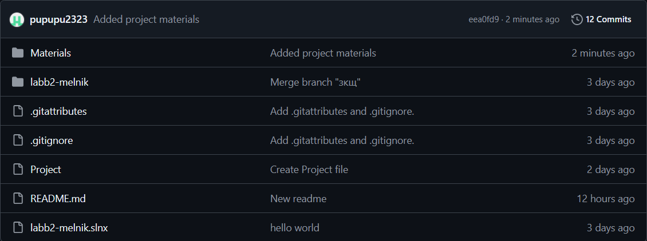
README.MD
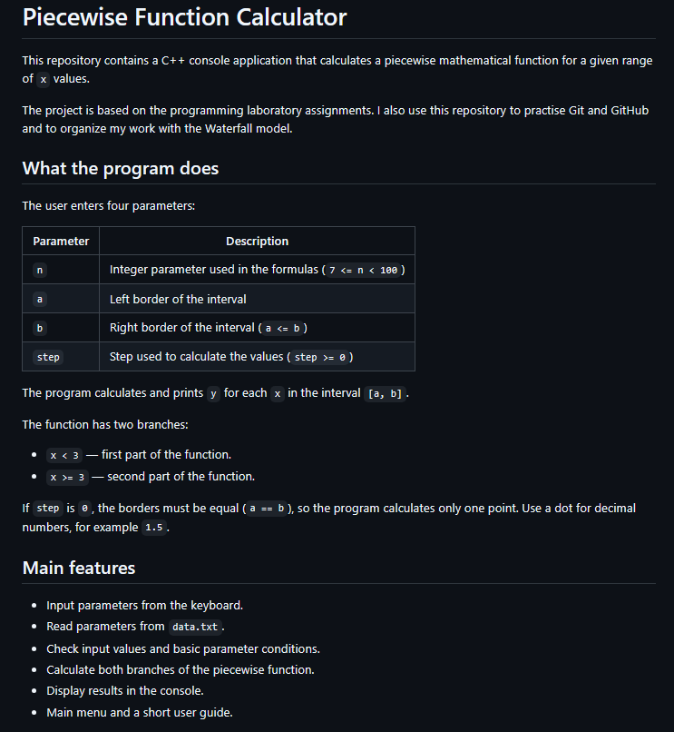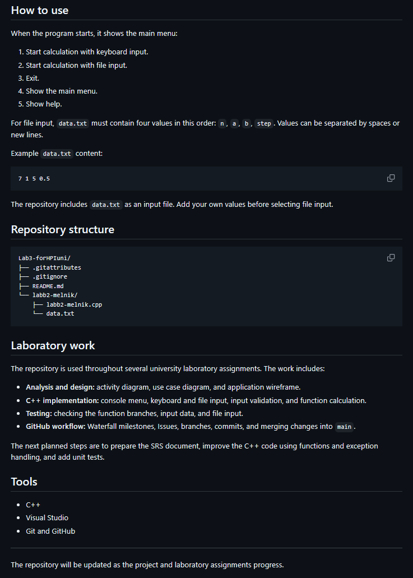
3 Project Management Using the Waterfall Model
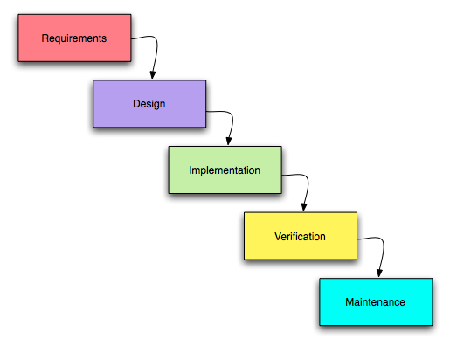
- Milestones — development stages.
- Epics — groups of related tasks.
- Subtasks — individual activities within each Epic.
4 Milestones and Issues
4.1. Milestone 1 - Requirements Analysis (Lab 1)
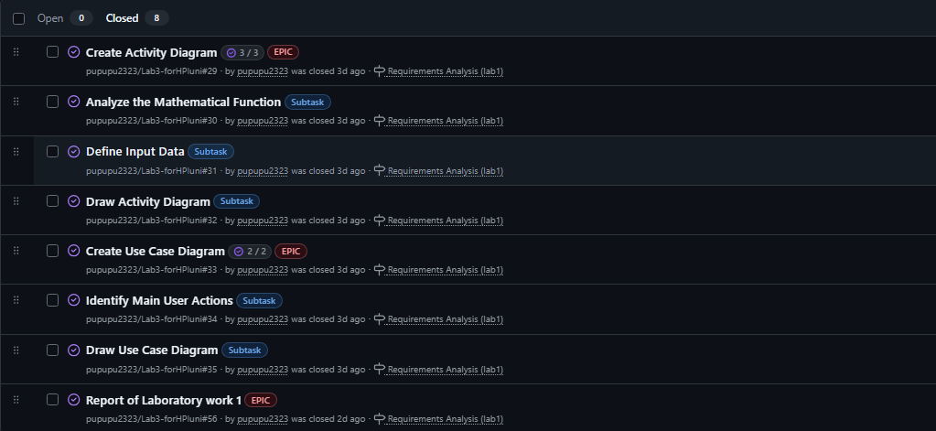
4.2. Milestone 2 - System Design and Implementation
(Lab 2)
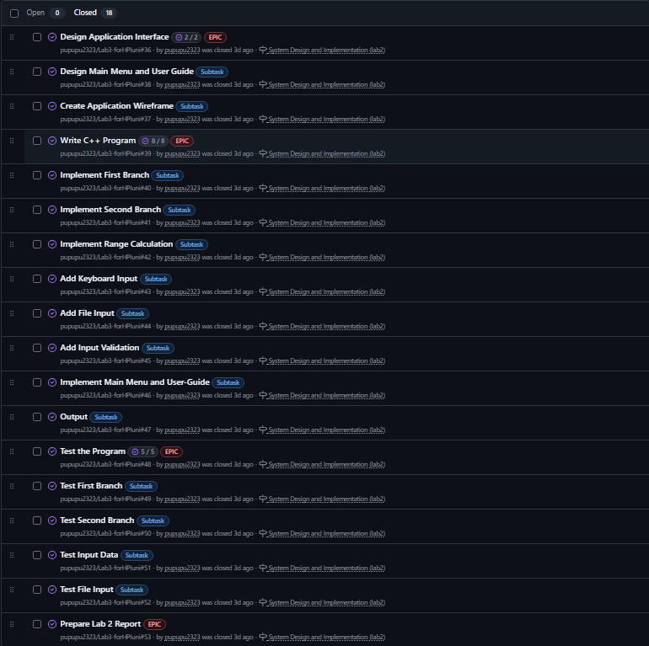
4.3. Milestone 3 - Create GitHub Repository (Lab 3)
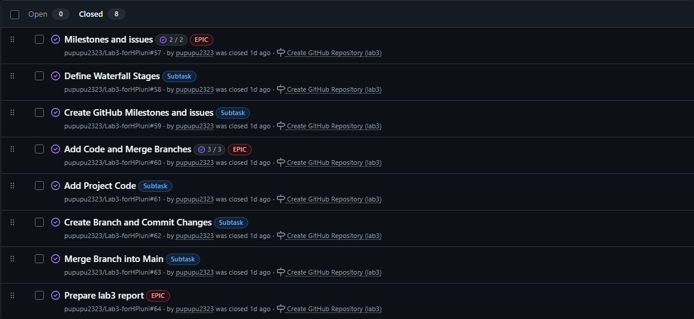
4.4. Milestone 4 - Software Requirements Specification (Lab 4)
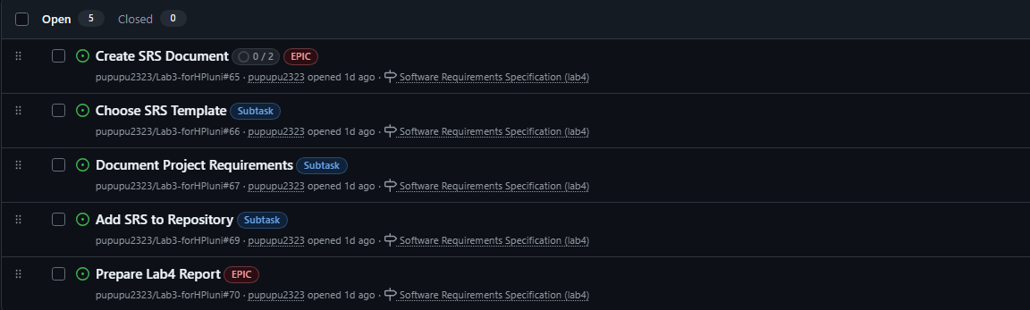
4.5. Milestone 5 - Code Improvements and Unit Testing (Lab 5)
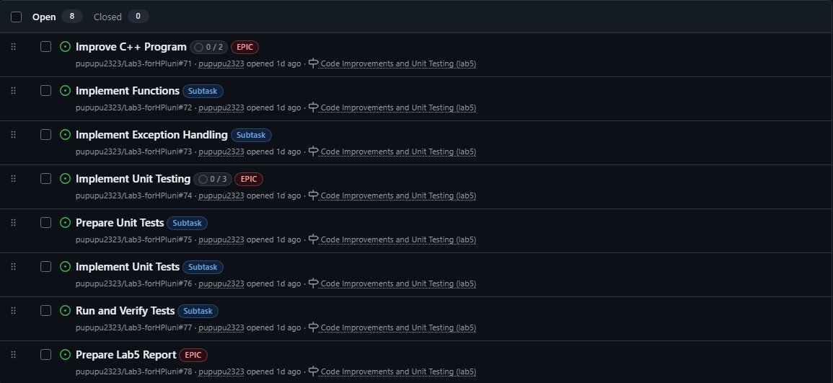
5 Working with the Git Repository
5.1 commits
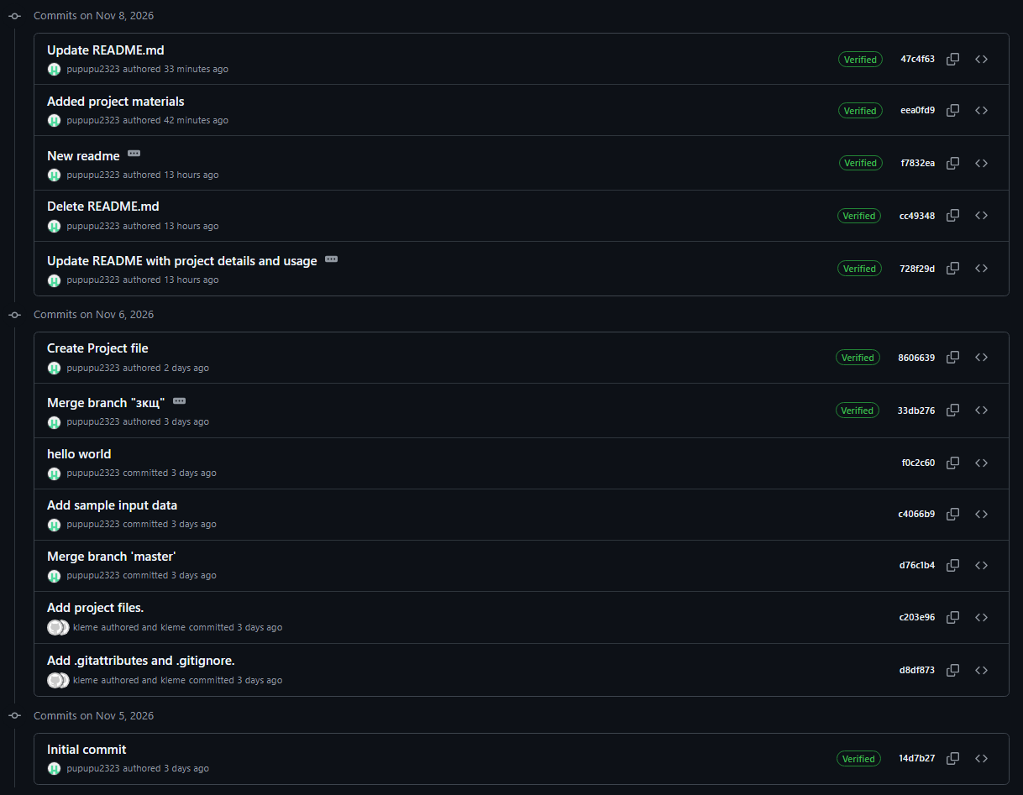
5.2 sourse code
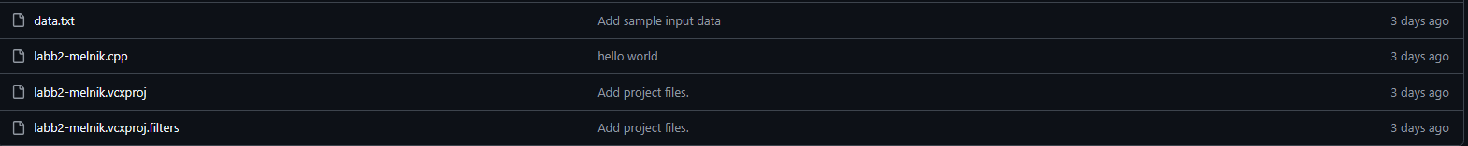
5.3 materials
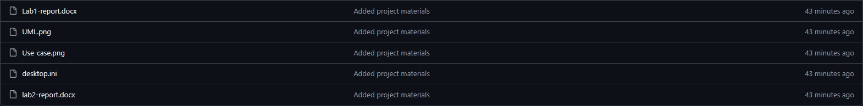
6 Creating and Modifying a Branch
To demonstrate Git version control, a separate development branch named зкщ was created from the main branch.
After creating the branch, the source code file labb2-melnik.cpp was modified by adding the comment //hello world.
The changes were committed with the message hello world and pushed to the GitHub repository.
After that, the development branch зкщ was merged into main. The merge was completed successfully, and the added comment became available in the main branch.
This demonstrates the basic Git workflow: creating a branch, modifying files, committing, pushing and merging changes into the main branch.
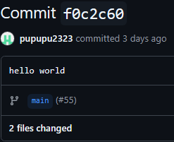
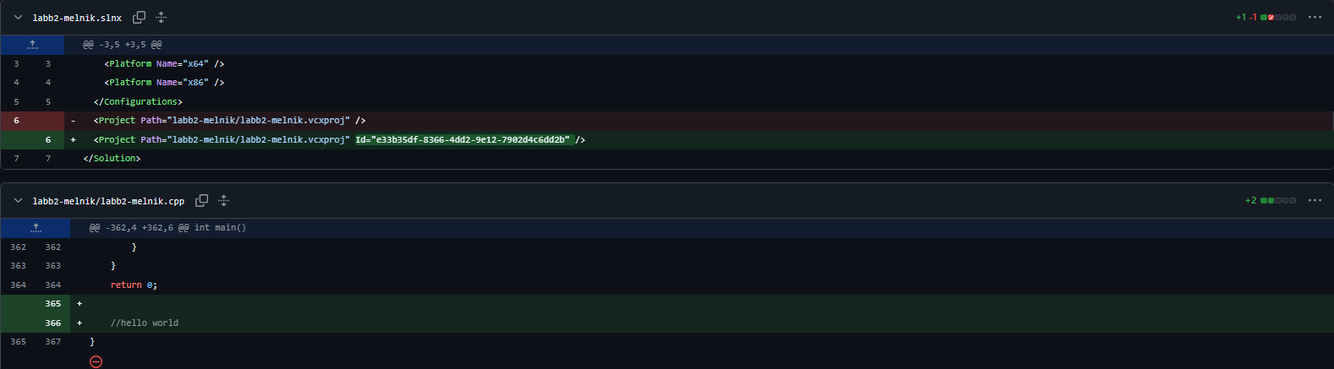
Conclusions
During this laboratory work, experience and knowledge of using GitHub as a project tracking and version control system were obtained.
The project repository was created and organized using the Waterfall development model. Milestones, Epics and Subtasks were used to divide the project into development stages and individual activities.
The basic Git operations, including adding files, creating branches, committing, pushing and merging changes into the main branch, were also practiced.
\

